**US Citizenship Eligibility Worksheet:**

The attached “Eligibility Worksheet” will help you decide if you are eligible to apply for naturalization. Do not send the completed worksheet to U.S. Citizenship and Immigration Services (USCIS). You should complete this worksheet if you are 18 years of age or older and are thinking about applying for naturalization based on your years as a Permanent Resident, you should complete this worksheet.

**Directions for the Eligibility Worksheet:**

1. Answer the questions on the worksheet by checking “True” or “Not True”. If you answer “Not True” to certain questions, you may be asked to answer additional questions on later pages. Most applicants will not need to answer these later questions.
2. If you have completed the worksheet and believe you are eligible for naturalization, please proceed to the next section of the guide where you will find instructions on filling out your N-400 (Application for Naturalization).
3. If you have completed this worksheet and you still have questions regarding your eligibility, you should read *A Guide to Naturalization*. You may also wish to get advice from an immigrant assistant organization.

**US Citizenship Eligibility Worksheet:**

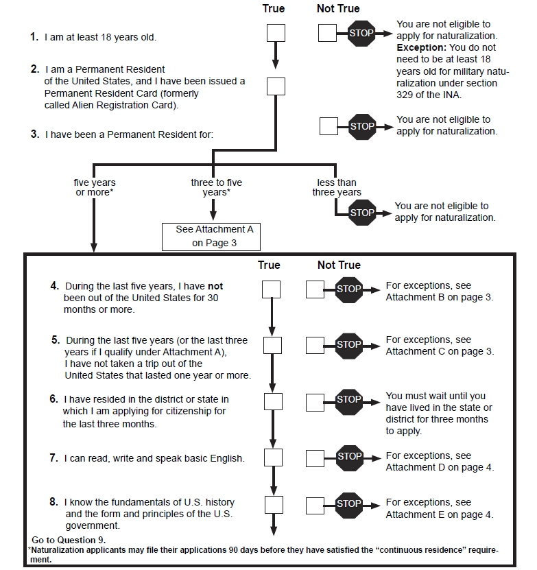

****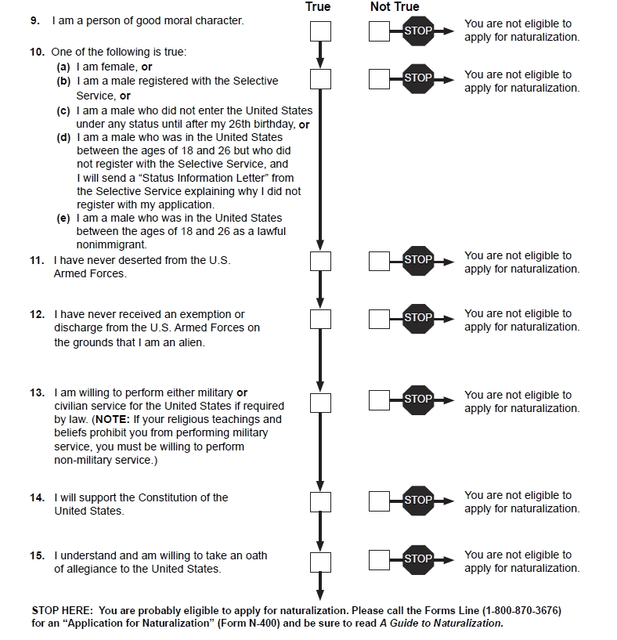

Attachment A – Naturalization Eligibility Worksheet:

Attachment B:

Attachment C:

Attachment D – Naturalization Eligibility Worksheet:

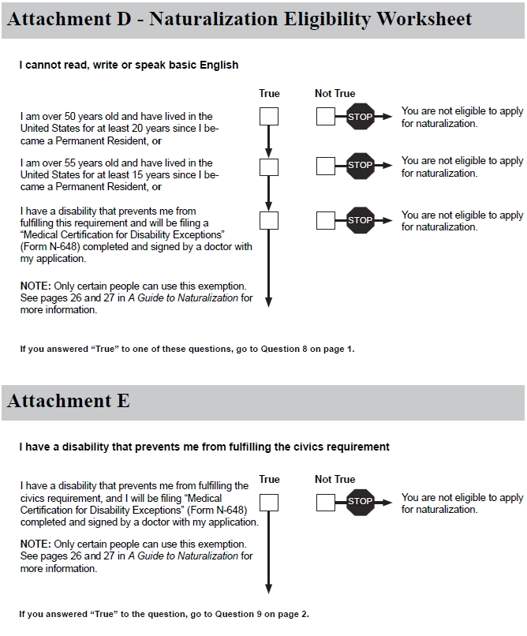

Attachment E:

